**Code Explanation for Converting an image to GrayScale**

**import cv2**

**import matplotlib.pyplot as plt**

**# Read the image**

**image = cv2.imread('C:/Users/asus/Desktop/Tuwaiq Academy/Dr. Afshan/horse.jpg') # Give the path to your image**

**# Convert the image to grayscale**

**gray_image = cv2.cvtColor(image, cv2.COLOR_BGR2GRAY)**

**# Display the grayscale image using Matplotlib**

**plt.figure(figsize=(6, 6))**

**plt.imshow(gray_image, cmap='gray')**

**plt.title('Grayscale Image')**

**plt.axis('off') # Hide axes for better visualization**

**plt.show()**

**Output**

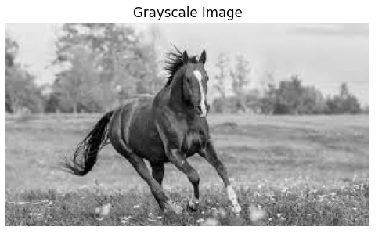

1. **Importing Libraries:**

cv2 (OpenCV) is used to read and process the image.

matplotlib.pyplot (as plt) is used for displaying the image.

1. **Reading the Image:** The image is loaded using cv2.imread('C:/Users/asus/Desktop/Tuwaiq Academy/Dr. Afshan/horse.jpg'). It is important to provide the correct path to the image file.
2. **Converting to Grayscale:** The code converts the original image to grayscale using:

gray_image = cv2.cvtColor(image, cv2.COLOR_BGR2GRAY)

This reduces the image to a single channel representing the intensity (brightness) of each pixel.

1. **Displaying the Grayscale Image:**

plt.figure(figsize=(6, 6)) sets the size of the displayed figure (6x6 inches).

plt.imshow(gray_image, cmap='gray') displays the grayscale image with the colormap set to 'gray'.

plt.title('Grayscale Image') adds a title to the image.

plt.axis('off') hides the axes for a cleaner view.

plt.show() displays the image.